Data Pooling Training Manual

Commercial in Confidence telcoinabox.com.au Page 1 of 26

Prima Mobile Data

Pooling
Training Manual
May 2022
Version 2.0

Introduction

What is Data Pooling?

Data pooling is a product construct that is great for businesses with large numbers of mobile subscribers. Subscribers who are enrolled into a data pool can contribute their mobile plan data allowance for use by others in the pool.
This allows businesses to leverage the scale of their user-base, where they may have some low-data-use subscribers who don’t typically use much or any of their quota, and some higher-use subscribers, combining all their quotas for use by everyone in the pool.
Provider Pool Service
Mobile 10GB
Mobile 20GB
Mobile 40GB
Combined Pool Amount = 70GB

What are the benefits?

Mobile data pooling allows a service provider to target business-type customers who have multiple subscribers. Subscribers can be added to a pool to share data and individual usage limits can be set.
- Businesses don’t need to put all of their subscribers onto high-use data plans if they don’t consume large
amounts of data, which may lower their overall costs.
- Lower use subscribers can tap into a bigger pool of data if they occasionally need it, meaning they don’t run
out of data or need to change plans.
- Individual usage limits can be set; for example, a 3GB consumer might have a 5GB limit set, so they don’t
consume significantly more than their plan contribution allows.
- Easily add or remove subscribers as the businesses’ needs evolve, all within the Octane portal.

Data Pool example:

10x users with 3GB data (30GB) 10x users with 40GB data (400GB)
Total combined data across all subscribers = 430GB

Individual limits example

E.g.: 3GB users can have an artificial limit set of 10GB

Key Conditions

- Customers can have up to 200 users per pool.
- If a service provider has a customer with more than 200 users, they can create additional pools to share the data amongst the pool of users.
- Intended for use with related end-customers (e.g.: a business with 50 staff can enroll 50 users into a pool).
- End-customer notifications for TCP Code will go to the provider of a service only, so monitoring usage will only be possible by the primary user of the account.
- Product is not intended for use as a “Data aggregation” type model where a Service Provider can enroll all of their individual customers into a pool (e.g.: subscribe to 1GB plan but label it 10GB) and prop the pool up with 10x 100GB plans.
- Does not have “data banking” or rollover features; the data pool will be forfeited at the end of each billing
period based on the pool’s anniversary date.
- All pooling services will need to have the same anniversary date as the pool to ensure that the date that inclusions are added/refreshed will be aligned (typically the 28th day of each month).

- Customers plan changing onto a pooling plan will forfeit any previous data inclusions they may have had on their plan. Customers may choose to schedule the plan change to occur on the 27th to avoid forfeiting previous inclusions.
- Services that opt out of a data pool will lose their data contributed to the pool and will need to plan change to a non-pooling plan to restore any data balance.
- Only services on pool-compatible plans will be allowed to join a pool. If a service is on a non-pool compatible plan it will first need to be plan changed before it can be added to the pool.

 |  |  | National Calls | IDD Inclusion | Data Inclusion
Mobile Pooling – 3GB |  |  | Unlimited | N/A | 3GB
Mobile Pooling – 10GB |  |  |  | N/A | 10GB
Mobile Pooling – 20GB |  |  |  | Unlimited  to select destinations | 20GB
Mobile Pooling – 40GB |  |  |  |  | 40GB
Data Top up (auto top-up) |  |  | N/A | N/A | 10GB
 | Pooling Provider Setup Fee (onetime fee per Pool)

Provisioning a Data Pool Service

Create Data Pool

A data pool exists as an individual service within Octane. We call this the pool provider service. This service must be created before any services can be added to the pool. Services added to the pool are called pool consumers. Services must be on the same account in Octane in order to share data.
Login to Octane and navigate to the customer you would like to create a pool on.

Navigate to the Sell menu and select Mobile
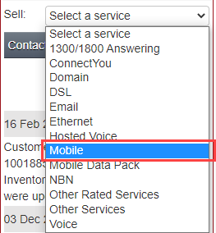

Select Telstra WME as the carrier and Data Pool as the Creation Type.
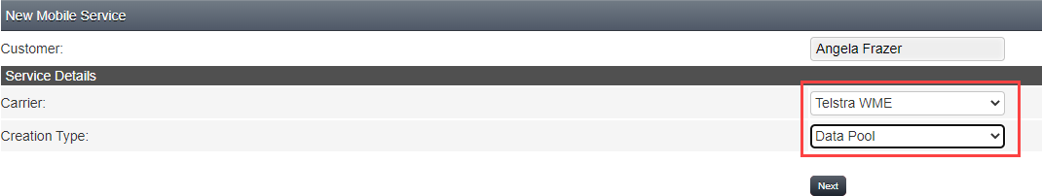

Enter the following information:
- Pool Name - this is mandatory and will appear on the invoice as the name of the pool provider service.
- Department – this is optional and allows you allocate the pool provider service to a cost center.
- Rate Plan - Select a Rate Plan for the pool provider service. You will have 2 options for provider rate plans. You can choose to create a pool with auto data block or without auto data block. Select the appropriate plan for the customer.
- Usage Notification Email – Enter the email address that you would like to receive notifications for the pool provider service. This is the only email address that will receive notifications about the pool data usage and is mandatory.
- Service Notes – Enter any notes that you would like to store against the service. This is optional.
Note that there is a one-time setup fee to create a data pool. The wholesale cost of the pool will be indicated on the page.

Click Submit.
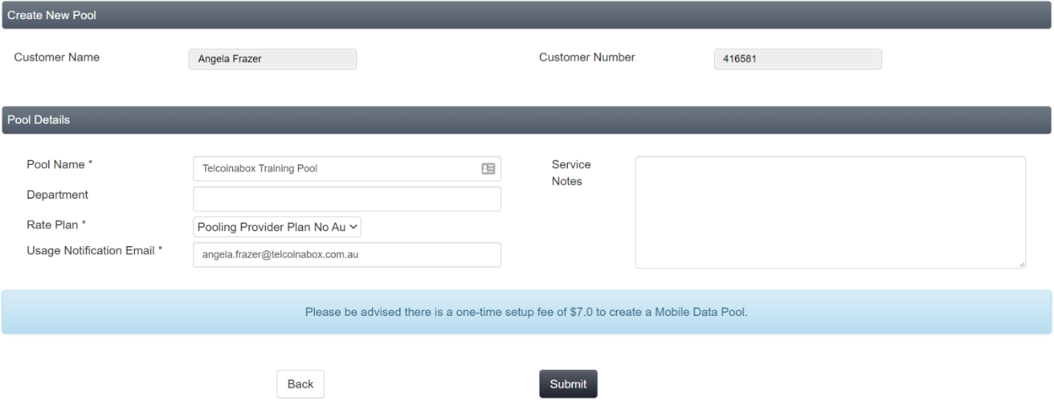

Press Yes to confirm that you want to create a new data pool.
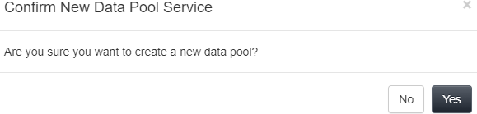

You will see a confirmation that the order to create the pool has been made. Orders can take up to 20 minutes, however are normally complete within 5 minutes.
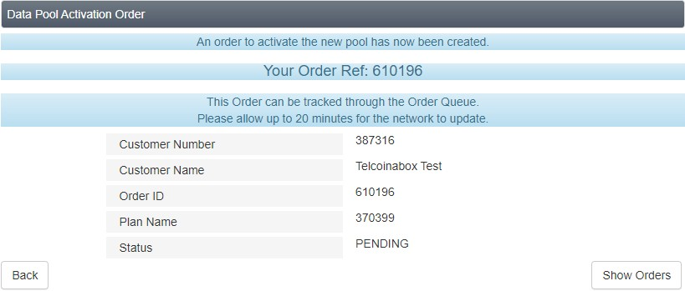

Add services to a Data Pool

Important: You can only add services to a pool if they are on a pool compatible plan. Make sure the service you want to add to the pool is on a pooling plan before you attempt to manage the pool. If the service is not on a pooling plan you will need to perform a plan change to a pooling compatible plan first.

Note: When plan changing to a pooling plan, any previous data will be forfeited and the service will have access only to the amount of data in the data pool.
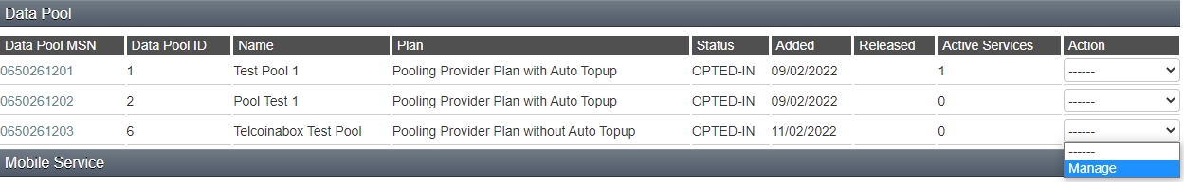Find the pool you wish to manage on the Services page in the Data Pool section and select Manage from the Action dropdown.

Select Manage Pool from the action dropdown.
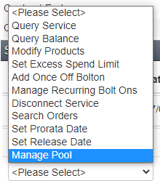

Select Add Service from the menu on the right-hand side of the Manage Pool page.
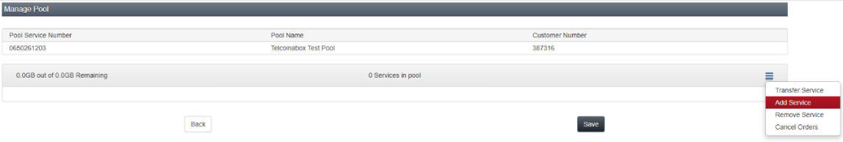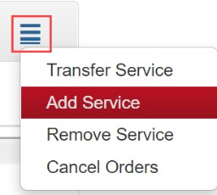

You will now see all services on the account that are eligible to be added to the pool. In order to be eligible, the services must be:
- Active
- Not already part of a pool

- On a pool compatible plan
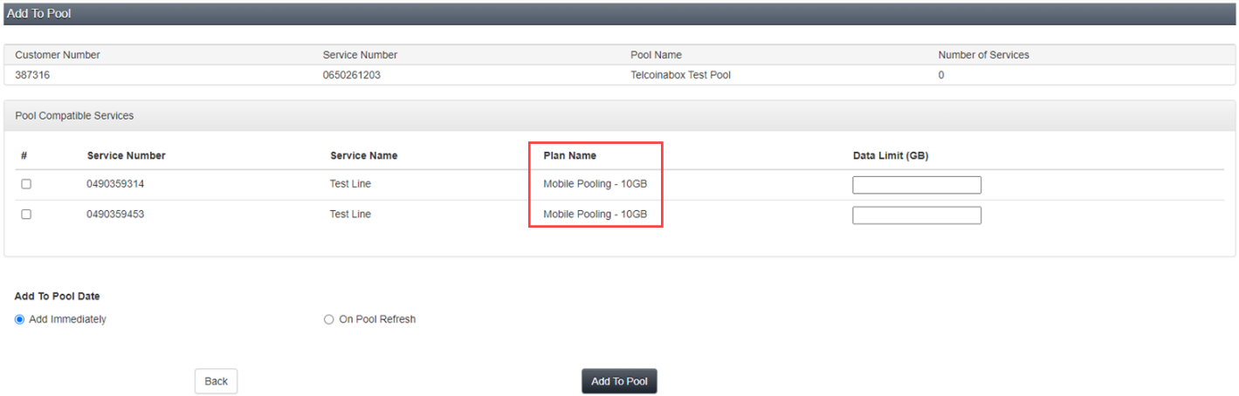

You can choose to add one or more services to the pool at the same time by clicking the checkbox next to the service number.

You can also choose to add a Data Limit (GB) to each service.
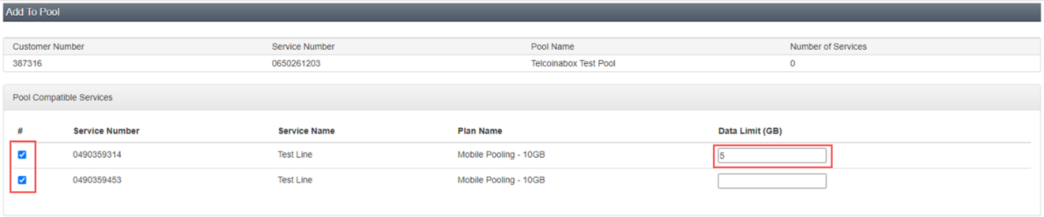

This data limit will limit the amount of data that each individual service can use from the pool. If you do not want a data limit on a service, you can leave this blank.
Note: Once a data limit is added to a service, it cannot be removed.

Once you have selected the services and optionally added a data limit, you can choose to add the services to the pool immediately or wait until the pool refreshes.
- Add Immediately
i. This will immediately add the services to the data pool. This means the services will no longer have individual data and their data will be transferred to the pool to be shared amongst all users of the pool.
- On Pool Refresh
i. This will queue the services to be added to the pool the day before bill run and prior to their refresh, so they can begin using shared data when they all have full balances.

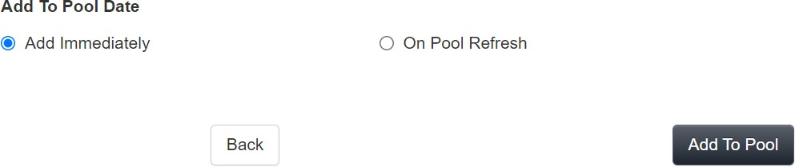

Once you’ve clicked Add To Pool, you will see a confirmation that orders to add the selected services to the pool have been submitted. Orders typically complete within 5 minutes.
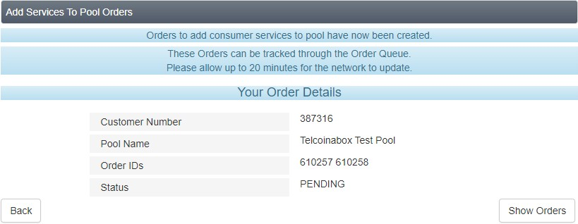

How to Manage Data Pool
Once you’ve added services to the pool, you will see some changes in the Services page. You will be able to see how
many Active Services are in the pool and the Data Pool ID
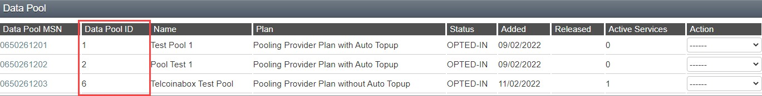

You will also see the Data Pool ID reflected on the individual services. This way you can quickly see which services are in a pool.
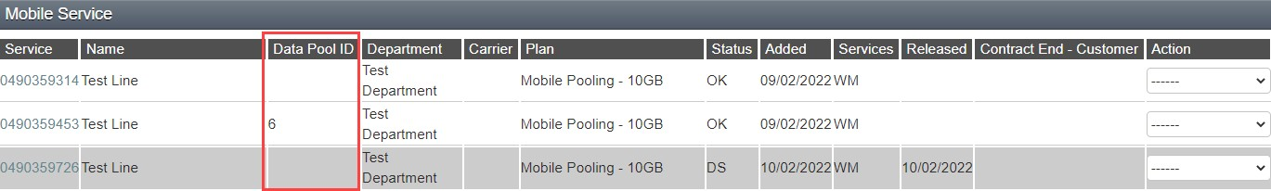

Select Manage from the actions menu to view further details about the pool and perform the following actions:
- Add more services to pool
- Remove services from pool

- Transfer services to another pool
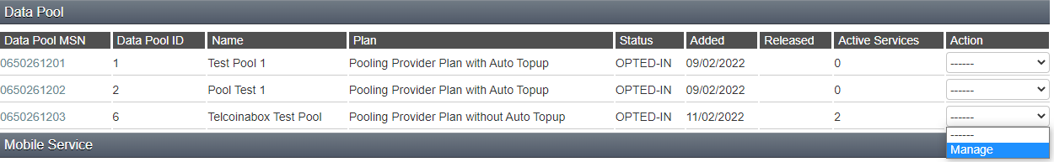

Select Manage Pool from the action dropdown.

Now that you have added services to the pool you will see additional data on this page:
- Total data in the pool and the amount remaining
- Number of services within the pool
- Individual services that are in the pool and their status
- Data limit of each service
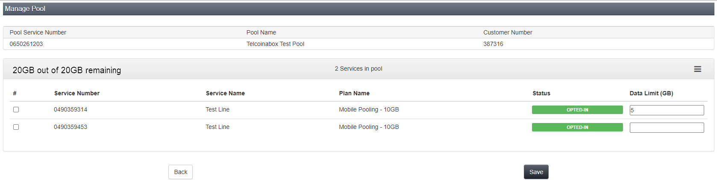

Update Data Limit

To update the data limit of one or more services, simply type a new data limit (in GBs) and click Save. Note that there is no way to remove a data limit once one has been set. The alternative is to set a very high data limit on the service if

you no longer wish to limit the service to a portion of the pool’s data. For example, if the pool has a max of 80GB you
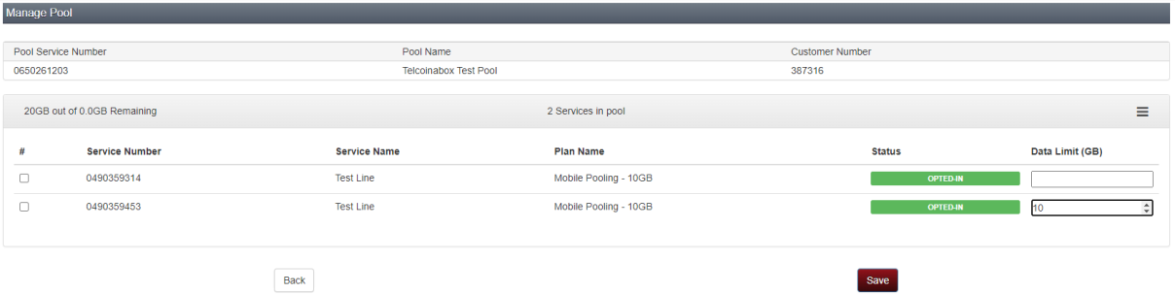
could set a data limit of 80GB which would be equal to the service not having a data limit set. You will see a confirmation page that the order has been submitted.
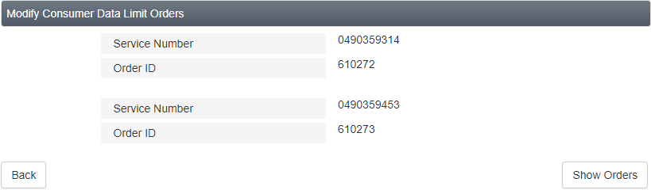

Remove Services from Pool

To remove services from a pool, go to the Manage Pool page, click the checkbox next to the service/s you would like to remove, select Remove Service from the menu on the right-hand side of the page and click Save.
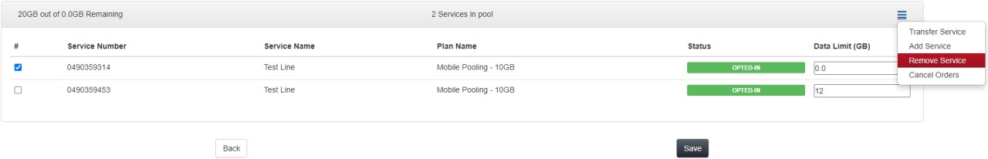

Note: When you remove a service from a pool, it will not have any individual data, as it has already given all its data to the pool. The service will receive data again when it refreshes for the month (at the time of bill run).

For this reason, you can choose to remove the service immediately, or you can wait until the day before the bill run. To remove the service the day before the bill run, select On Pool Refresh.
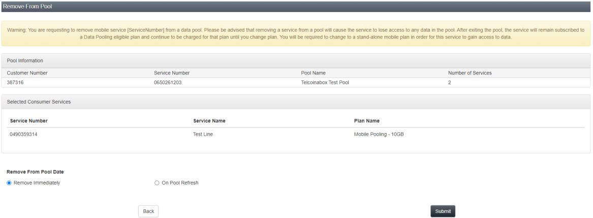

Once you click Submit you will see an order confirmation page:
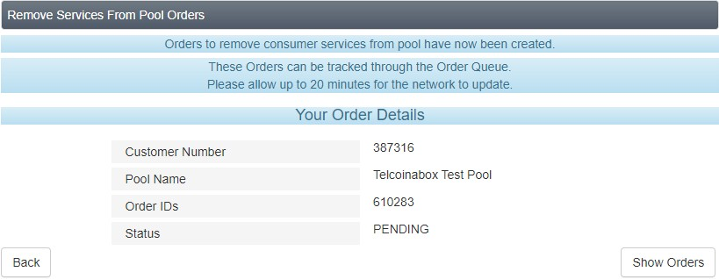

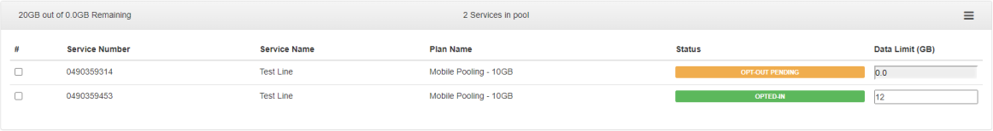When you manage the pool now you will see that the service has been removed if the order is complete. Alternatively, if the order is still in progress, you will see that the service has a status of Opt-Out Pending.

Once Serviced is removed from Data Pool, please change to a suitable standalone plan

Transfer Service to Another Pool

If you have set up multiple pools for the same customer, you can transfer a service from one pool to another. To do this, go to the Manage Pool page.
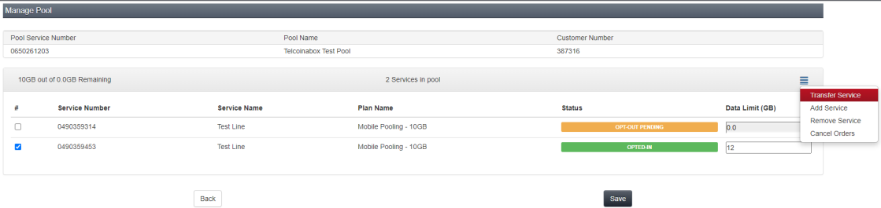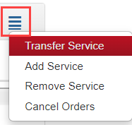Select the checkbox next to the service you wish to transfer and select Transfer Service from the menu on the right- hand side of the page.

You will see a Transfer Service page which shows details of the service you have selected to transfer. You will also see all the available pools on the same customer account that you are able to transfer to.
Tip: If you do not see any available pools, it means you need to create a second pool on the account.

Tip: A pool can have a maximum of 200 services. If your request would result in a pool that has more than 200 services, you will receive an error and will not be able to proceed.

Select the pool you would like to move the service to and choose whether to Transfer Immediately or On Pool Refresh.
Note: If transfer immediately is selected, the service will not add any data to the pool you are transferring to as it has already given its data to its first pool. If you wish to wait until the service refreshes so it can contribute data to the pool, select to transfer On Pool Refresh
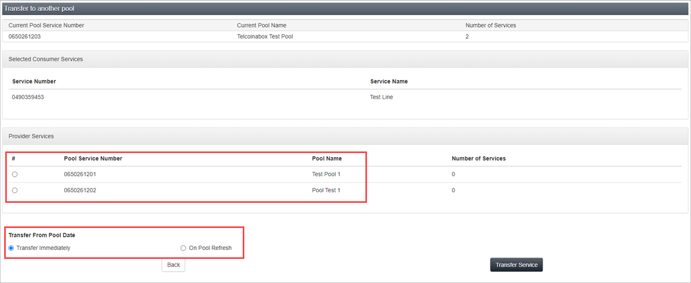

Click Transfer Service.
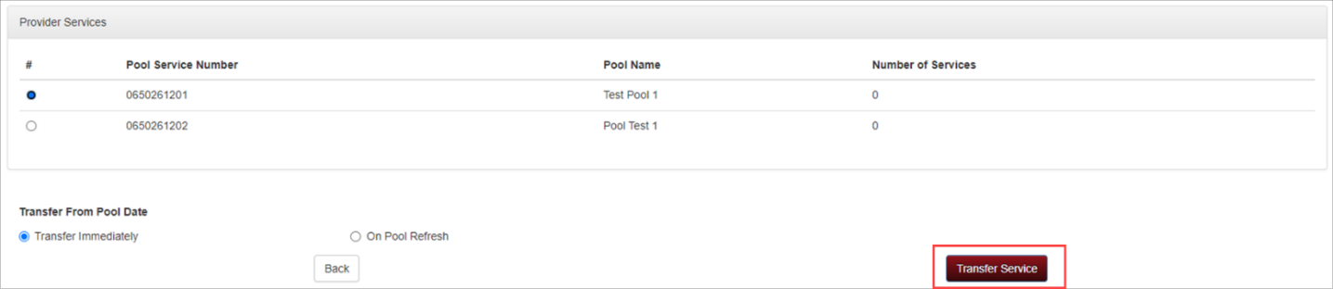

Click Yes to confirm that you would like to transfer the service/s to another pool.
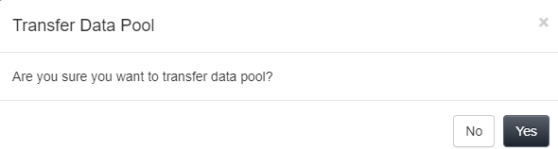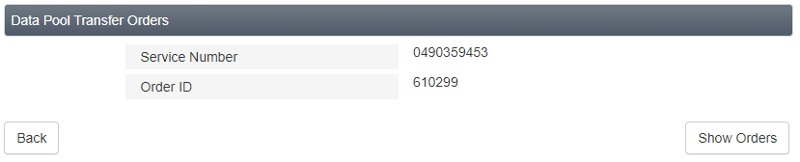
You will see a confirmation that the order has been submitted.

Cancel Pending Orders
If you have incorrectly requested a service be added to, removed from or transferred out of the pool, you can cancel the order providing that it is still in a pending status.
Go to the Manage Pool page.

If the status of the order is one of the following, you can attempt to cancel the order:
- OPT-IN PENDING
- OPT-OUT PENDING
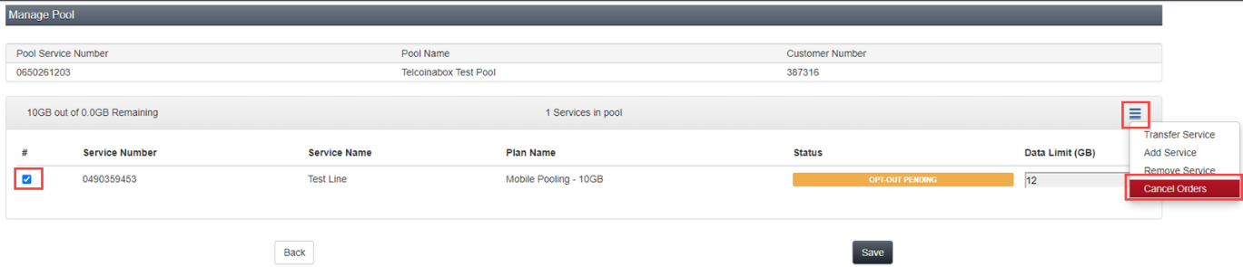Select the checkbox next to the service/s which have the orders that you would like to cancel. Select Cancel Orders from the menu on the right-hand side of the page.

Confirm by selecting Yes that you would like to cancel the selected order/s.
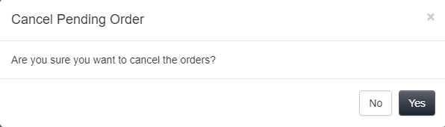

If your request is successful, you will see a success message at the top of the page:

If your request has been unsuccessful, you will see an error message at the top of the page:

Tip! Orders are generally picked up within 5 minutes. Once the order has been picked up and moved from Pending to Committed, you will not be able to cancel the order. You can only cancel the order if it is still in a pending state and has not yet been picked up for processing.

Report on Pool
Go to Reports > Service to find the available data pool reports.
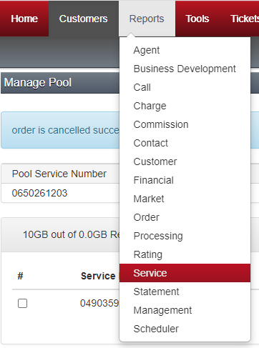

Here you will find 3 reports that can be used to gain insight into how your customers are using their data pools:
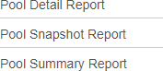

Pool Snapshot

The Pool Snapshot will provide an overview of all pools so that you can see averages of data usage across all the pools that exist within your group.
Select the Pool Snapshot report and select the required date range. The Pool Snapshot will show you the following columns:
- Service Provider Name
- Count of pools

- Average number of subscribers per pool
- Average amount of data consumed per pool
- Average count of auto top ups per pool

Pool Summary

The pool summary report will provide a summary of each pool. It will show you the following columns
- Group Number
- Service Provider Name
- Octane Customer Number
- Pool Identifier
  - The ID used to identify the pool within Octane
- Provider Service Number
  - The private MSISDN that is used to provision the service
  - Pool Name
  - The name of the pool that was provided upon activation of the pool
- Count of Consumers
  - The number of services within the pool
- Total Data Used
  - The total amount of data used for the period selected
- Total Number of Auto Top Ups
  - The total number of auto top ups for the period selected

Pool Detail

The pool detail report will show detail of each service that is within a pool including a historical view of the usage within the pool (depending on the date selection that you use), as well as when the service was added to or removed from the pool. This report can be run for the current month, for the last 3 months or the last 6 months.
The Pool Detail Report will show you the following columns:
- Service Provider Name
- Octane Customer Number
- Pool Identifier
- Provider Service Number

- Pool Name
- Consumer Service Number
- Consumer Service Name
- Consumer Plan
- Consumer Data Limit
- Date Added to Pool
- Date Removed from Pool
- Data Used
  - Current Period (unbilled)
  - Previous Month 1
  - Previous Month 2
  - Previous Month 3
  - Previous Month 4
  - Previous Month 5
  - Previous Month 6

Disconnect Pool
You can disconnect a pool if it is no longer required.

Note: A pool provider service cannot be disconnected if there are any services connected to the pool. You must first remove or disconnect any services that are within the pool before you proceed with disconnection.
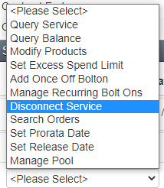To do this, find the pool service you wish to disconnect and select Disconnect Service from the actions menu on the Service Number Details page:

You must select Yes to confirm you wish to disconnect the pool.
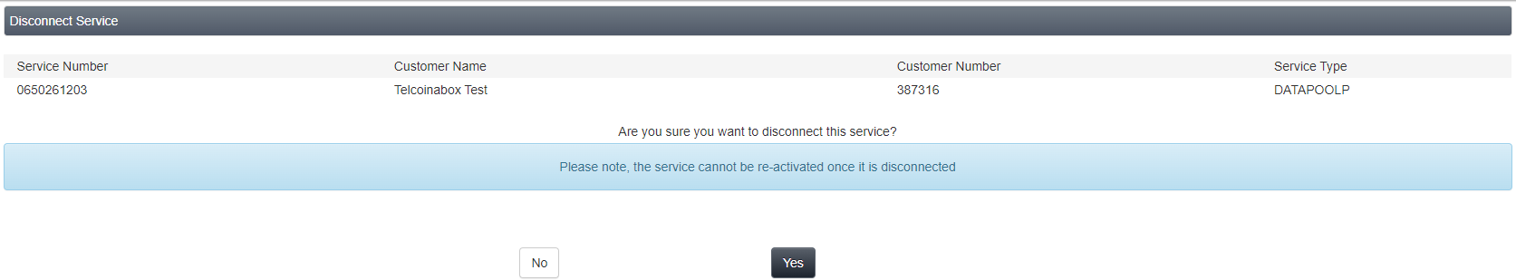

FAQs

Q: What plans are eligible for data pooling?

A: Our Mobile Data Pooling plans as made available in Octane from time to time

Q: How can I create a pool?

A: Ensure the service you wish to enrol into the pool is subscribed to a Pooling Eligible plan, and from the Sell service menu of Octane, select Mobile, and when prompted, select Telstra WME as the Carrier, and creation type as Data Pool.

Q: How can I manage a pool?

A: From the Services page in Octane, go into the Data Pool section, and select Manage from the Action drop down menu to enter Pool Management.

Q: How can a subscriber be enrolled into a pool?

A: From the Manage Pool screen, click “Add Service”, and select the services on the customer’s account to add.

Note: The subscriber must from the same customer account and be subscribed to a pooling eligible plan.

Q: Can a pooling plan be used stand-alone?

A: Technically Yes, a pooling plan will be allocated voice and/or data quotas based on the plan inclusions. If the customer wanted to, they could use the plan as stand-alone before enrolling into a pool.
It should be noted that a customer who opts out of a pool will have voice inclusions (if they’re part of the plan), but will not have any data after opting out of a pool, as the data was contributed to the pool. Customers opting out of pools should plan change to a non-pooling plan type.

Q: Can pooling services be used when roaming

A: Services that are part of a pool can roam internationally, however they will have an Auto Provisioned International Roaming Pack (APIR) applied. It is not possible to use any data from a pool when roaming.

Q: Can I pool services from different Octane accounts?

A: No, if a service wants to join a pool, it will need to be part of the same Octane account.

Q: Can pooling subscribers bank or rollover any un-used data from the previous month?

A: No, the data pooling product does not have a data banking feature.

Q: What happens if a service within a pool is disconnected or ports away?

A: The service will disconnect or port out per normal processes, however any data that was contributed into the pool will remain unaffected.

Q: I have a customer with more than 200 users they want to add to a pool – what can I do?

A: If you have customers with more than 200 users, you can create another pool and add other subscribers into the second or subsequent pool/s.

Q: Can I transfer a service between multiple pools?

A: Yes, if you have a subscriber in one pool, you will be able to transfer them between pools if required, from the Manage Pool page in Octane, select the checkbox next to the service you wish to remove, and from the action menu, click transfer service, then select the pool you wish to transfer it to. Refer to the Data Pooling User Manual for more detail.

